Batch: C1 Roll No.: 16010122221

Experiment No. 06

Grade: AA / AB / BB / BC / CC / CD /DD

Signature of the Staff In-charge with date

Title: To implement XOR LOGIC using perceptron network. .
___________________________________________________________________________________
Objective: Implement multilayer perceptron for XOR function with binary inputs and target.
___________________________________________________________________________________
Expected Outcome of Experiment:

CO2: Analyze various neural network architectures ____________________________________________________________________________________
Books/ Journals/ Websites referred: .

____________________________________________________________________________________
Pre Lab/Prior Concepts:
- Perceptron Model:
The perceptron is the simplest form of a neural network used for binary classification tasks. It uses a linear function to classify inputs into one of two categories. However, perceptrons can only solve problems that are linearly separable, such as the AND and OR functions.

- Linear Separability:
Linear separability refers to the ability to separate two classes of data points using a straight line. For example, functions like AND and OR are linearly separable, while XOR is not. XOR requires a more complex model, like a multi-layer perceptron (MLP), because the outputs cannot be separated by a single straight line.

- Design of Classifier Using Multi-layer Perceptron Model for XOR Logic of 2 Inputs:
  - A multi-layer perceptron (MLP) solves problems that are not linearly separable, such as XOR.
  - The MLP model introduces hidden layers between the input and output layers, enabling the network to perform non-linear transformations.
  - Each neuron in the hidden layer takes a weighted sum of the inputs, applies a bias, and uses an activation function (e.g., sigmoid) to introduce non-linearity.

- Truth Table for XOR Logic: The XOR function produces an output of 1 when the two inputs are different and an output of 0 when they are the same.
Input A | Input B | XOR Output
0 | 0 | 0
0 | 1 | 1
1 | 0 | 1
1 | 1 | 0

- Classifier Using Multi-layer Perceptron Network for Implementing XOR Logic for 2 Inputs:
  - The XOR logic cannot be solved by a single-layer perceptron due to the non-linear nature of the XOR function.
  - A multi-layer perceptron introduces one or more hidden layers, which allow the network to learn the XOR logic by applying non-linear transformations to the inputs.
  - The MLP classifier works by adjusting weights and biases through a process called backpropagation, iteratively refining the model until it produces the correct outputs for the XOR problem.

Code:
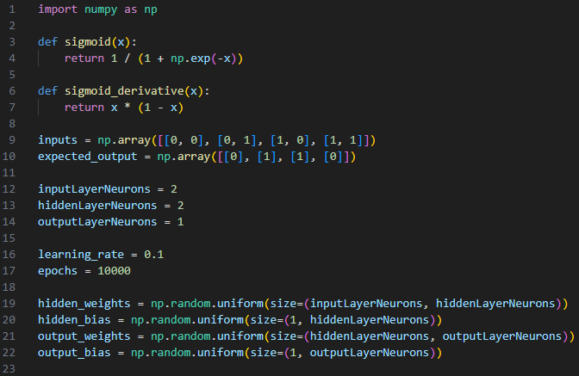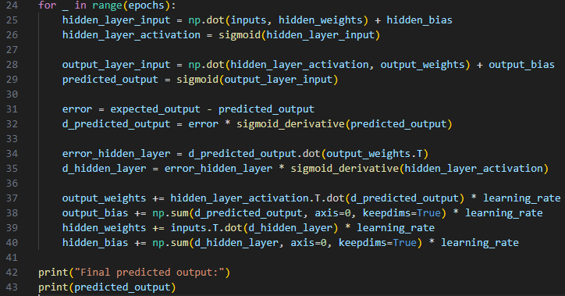

Output:
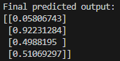

Conclusion: Thus, we have successfully implemented classifier using MLP for linearly non-separable XOR functions of 2 inputs

Post Lab Descriptive Questions:

- Why is XOR-logic function being Linearly notseparable?
The XOR logic function is linearly non-separable because its inputs and outputs cannot be divided into distinct classes using a single straight line or hyperplane. In XOR, the output is 1 when the inputs are different and 0 when they are the same. If you plot the XOR function on a 2D plane, with (A, B) as coordinates and the XOR output as the classification:
- (0,0) and (1,1) correspond to output 0.
- (0,1) and (1,0) correspond to output 1.
These points form a pattern that cannot be separated by a straight line. The 0s and 1s are positioned diagonally opposite each other, making it impossible to divide them using a linear boundary. To solve this, a non-linear classifier, such as a multi-layer perceptron (MLP), is required. The MLP introduces hidden layers that allow for non-linear transformations, making it capable of solving the XOR problem

- Design a classifier using MLP model for implementing NOT XOR logic

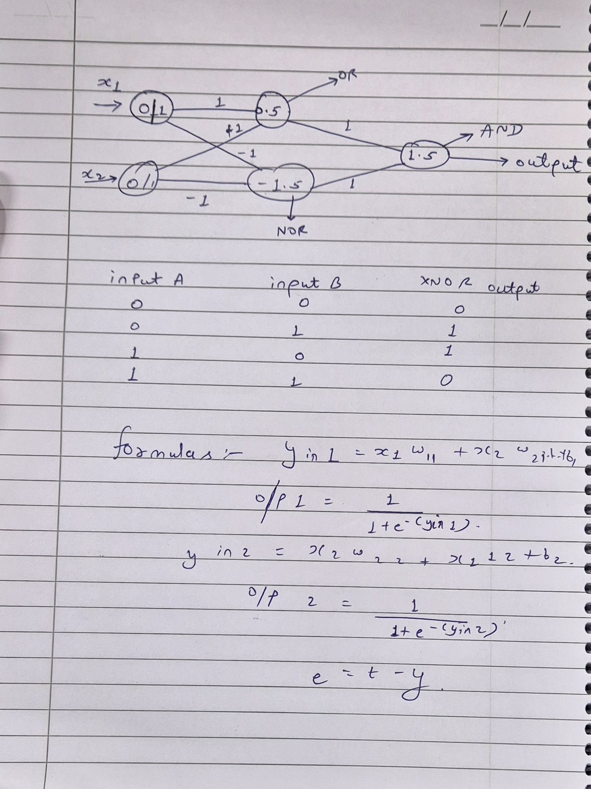

.

Date: _____________ Signature of faculty in-charge

